

Leadership Scholarship Programme
2026-2027 participant handbook

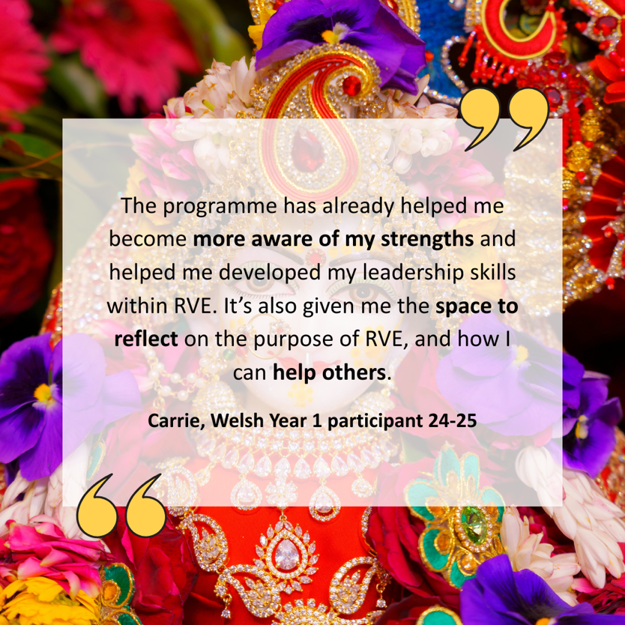

Contents

Helping you to find your voice as a leader 2

Developmental outcomes 3

Aims of the programme 3

Who is the Leadership Scholarship Programme for? 3

Why join the programme? Comments from past and current participants. 5

What am I committing to? 5

The review meeting 6

What’s involved in the programme? 6

What are the expected outputs? 8

Timeline 9

What is expected from your school? 10

How much does it cost? 10

How do I apply? 10

How is the programme managed? 11

Appendices 12

Helping you find your voice as a leader

The programme aims to help key influencers in the RE/RVE/RME/R&W community to find their voice and to shape a leadership community for the future to help bring about systemic change.

This programme not only equips leaders but builds a leadership community. The programme takes into account the following four areas of leadership:

- Research engaged: The power of knowledge
- Curriculum engaged: The power of the subject
- Classroom engaged: The power of practice
- Politically engaged: The power of influence.

The programme enables teachers/advisers to become skilled in all four areas but acknowledges that each leader may have one or two areas of passion and expertise. Teachers would bring these areas of focus to the leadership community of practice. The aim is that the leadership community of practice effectively utilises the expertise of each leader to bring about systemic change.

The programme helps Culham St Gabriel’s fulfil three of its current strategic objectives and therefore as a charity fulfil its obligations to the public benefit:
- Advocating for the importance of high-quality religion and worldviews education within the education world
- Empowering the current and next generation of RE/RVE/RME/religion and worldviews education teachers and leaders
- Fostering and nurturing collaborative partnerships within the religion and worldviews education community

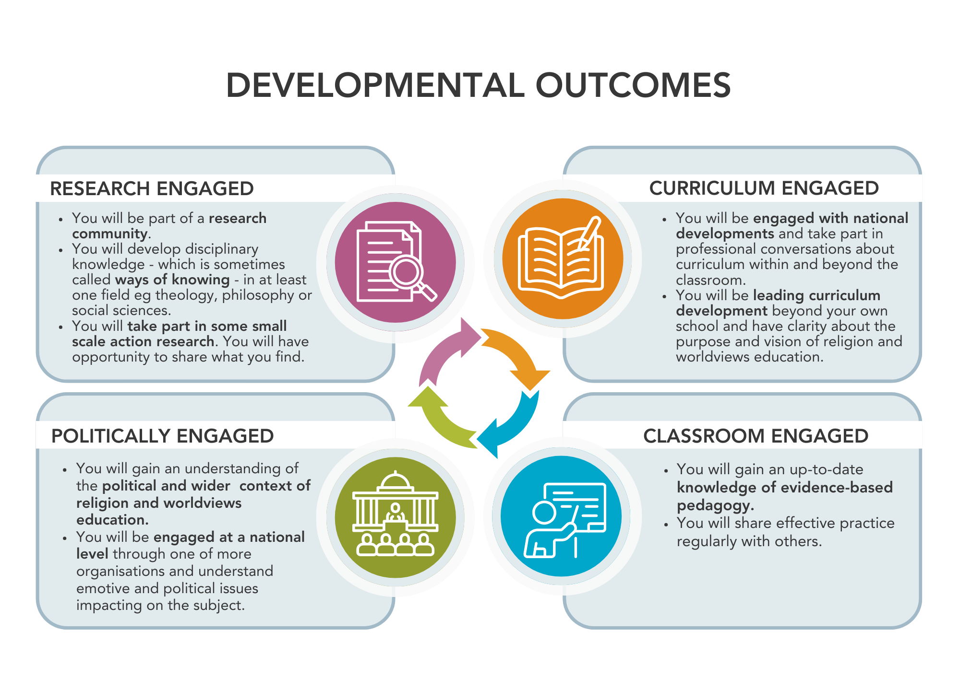

What are the aims of the programme?

To provide opportunities for emerging RE/RVE/RME/R&W leaders to expand and deepen their reflections on educational leadership in the subject, through receiving mentoring, structured challenges, research insights, inspirational networking events, and experience of professional development delivery.

Who is the leadership programme for?

The programme is for those who are working beyond their own school. It is designed for those who are already working or aspire to work across a MAT, local area, region or in a national capacity. For example, you might run a local group or hub for RE/RVE/RME/R&W teachers, you might lead the subject across a MAT, support teachers in a particular region or chair a local SACRE.

The programme is focused on leadership of RE/RVE/RME/R&W regionally and nationally, not on leading the subject within a school.

Why join the programme? Comments from past and current participants.

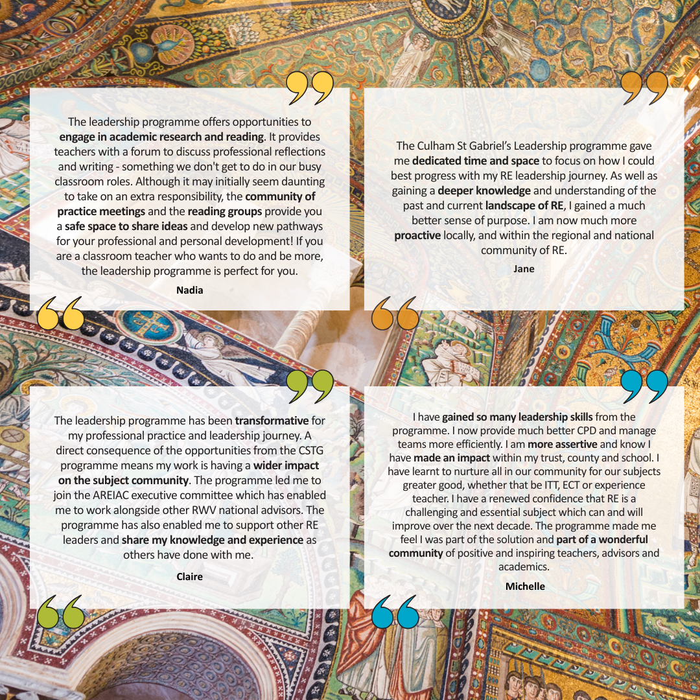

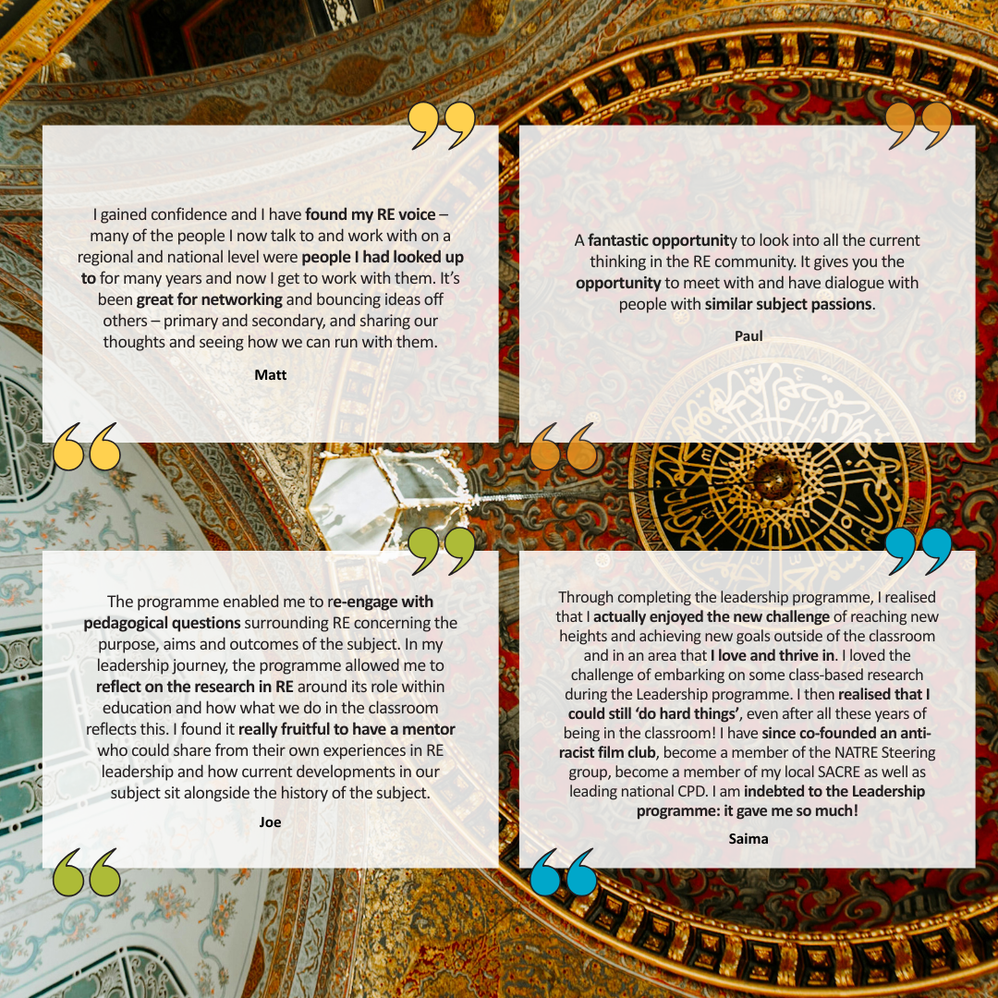

What am I committing to?

In Spring 2026, when you apply you will be signing up with the intention of committing two years (2026-2028) to the programme, but with flexibility built in. We have found the majority of our participants benefit from the programme most when they have two years of mentoring. The diagram below explains how the two-year programme process will work, and as you can see there is still an option to finish after one year.

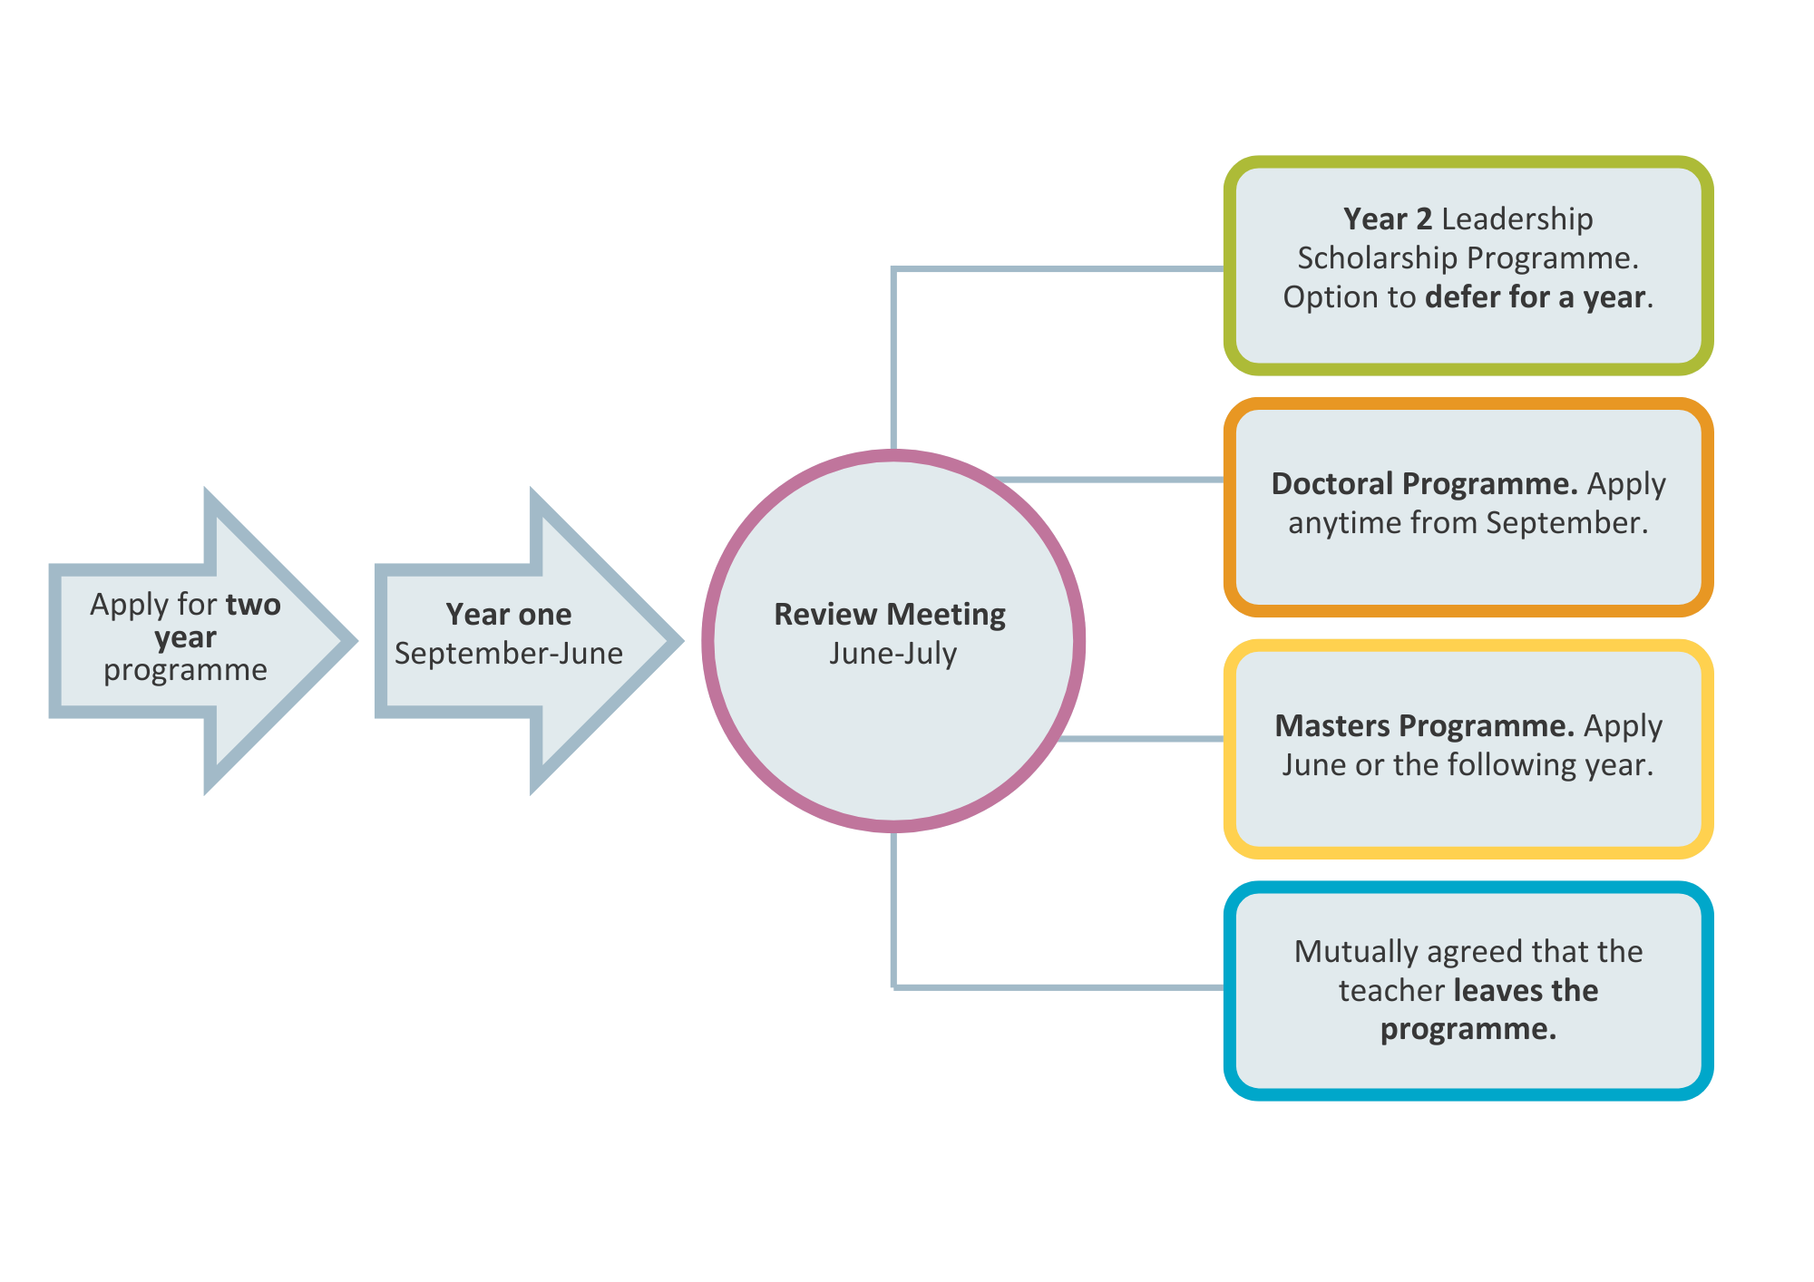

The Review Meeting

When you have completed the first year of the programme you will have a review meeting with your mentor and the programme lead. In this meeting you will chat through with them your next steps. This might be:
- Deciding together with your mentor that you will continuing on the leadership programme for a second year.
- Taking a ‘gap’ year 2027-28 and returning to the leadership programme in 2028-29 to do the second year. This might be because you want to consolidate on your learning, and/or because you have change in your personal or professional circumstances.This will be dependant on there being a space in that year.
- Moving to one of Culham St Gabriel’s other programmes e.g. the Masters Scholarship Programme.
- Deciding together with your mentor that one year has been of great benefit, but that for good reasons you wish to withdraw from the programme and not take up any of the other opportunities at the current time.
- Your mentor might feel that the second year of the programme is not appropriate and suggests that you end the programme in July 2027.

What is involved in the programme?

Mentoring

- You will be allocated a mentor who is already an adviser and/or national leader in the RE/RVE/RME/R&W community. You are expected to meet regularly with your mentor as part of this programme.
- You will complete an audit of need with your mentor and a development plan created which you will use as a focus for the first 12 months. You will use progress against this as a basis for your review meeting.
- Mentoring will take place for 12 hours between September and June. The time can be split in any way the mentee/mentor choose. These mentoring sessions will take place virtually.

E-Learning Courses

- During your first year, you will undertake at least three Culham St Gabriel’s Professional Development Short Courses of your choice which will be linked to your development plan. https://courses.cstg.org.uk Your mentor will support you through the course(s) providing professional dialogue. You should discuss with your mentor which courses to do and you can discuss your progress in mentor sessions.
- If these courses have already been completed the participant will, with their mentor, find other free on-lines courses that will help you in your leadership development.

Community of Practice

- You will take part in a virtual Community of Practice. This Community of Practice will include being part of a WhatsApp group and taking part in a series of four or five virtual meetings during the year, each taking 1.5 hours. These usually take place as twilights.
- In your first year you will have an extra face to face full day meeting In the Autumn term with your fellow participants focused on getting to know each other better and on understanding key developments In the world of RE/RVE/RME/R&W.
Please note this day will be held in London and the school will need to cover cost of supply for this day. Travel costs can be covered by Culham St Gabriel’s if needed.
- The Community of Practice may agree to hold further virtual conversations as a group to share course outcomes and present work or ideas to one another.
- There is a final ‘end of first year’ online gathering for feedback about the programme.

Research Reading Group

- You will take part in a virtual research reading group. This takes place over one term in Year 1 (in the summer term), and over two terms in Year 2 (in the Autumn and Spring terms). The sessions are as held as online twilights or evening meetings.

Other Opportunities

- Membership of AREIAC (Association of RE Inspectors, Advisers and Consultants) In Year 1
- Membership of AULRE (Association of University Lecturers in Religion and Education) in Year 2

In Year 2 the following elements will continue:

- Mentoring
- Community of Practice
- Research Reading Group
- Other opportunities, including attendance and presentation at national conferences.

In addition, in Year 2, you will also be supported by your mentor to carry out a researching practice project within your setting and have the opportunity to shadow your mentor or another suitable person for a day.

In Year 1 and Year 2 of the programme participants are expected to attend the AREIAC/AULRE joint conference, currently held in June. Culham St Gabriel’s will partially fund attendance up to £300 per participant which can be used for travel, the conference ticket cost and/or supply cover.

What are the expected outputs?

Outputs are connected to the four areas of leadership development.

Year 1
- Complete actions against bespoke development plan
- Complete CSTG short course on curriculum
- Complete a researching practice project within your setting.
- Complete one other CSTG short course of own choosing
- Blog about one of the four areas of leadership (curriculum, pedagogy, policy, research) for RE:ONLINE or another website such as NATRE/STARME
- Share new knowledge with a least two different professional groups e.g. a local network, SACRE, AREIAC group, conference
- Attend at least one SACRE, RE Council or other meeting which is policy related
- Join in with the WhatsApp group to help colleagues and deepen learning opportunities
- Participate in at least 75% at community of practice sessions and reading group sessions
- Report to CSTG about the impact of the programme on your leadership development.
Year 2
- Complete actions against bespoke development plan
- Shadow your mentor (or other national leader) for a day and work with them
- Complete a researching practice project within your setting.
- Present at a national conference on your research or other new learning
- Write for a national publication or journal e.g. RE Today, Professional Reflection, Chartered College Impact magazine
- Join in with the WhatsApp group to help colleagues and deepen learning opportunities
- Participate in at least 75% at community of practice sessions and reading group sessions
- Report to CSTG about the impact of the programme on your leadership development.
What are the expected outcomes for the participant? What will I get out of it?
By the end of the two-year programme, we expect you to have:
- Enhanced your regional/national profile within and possibly beyond the RE/RVE/RME/R&W community
- Increased confidence to lead RE/RVE/RME/R&W regionally and/or nationally
- Increased understanding of the importance of research, pedagogy, curriculum and political dimensions in leading the subject at a regional and/or national level
- Increased your contribution to national events
- Widened your horizons beyond the ‘classroom’ e.g. thinking beyond your own circumstances
- Increased your ambition for what is possible professionally
- Increased confidence and authority to speak into the public space about RE/RVE/RME/R&W e.g. through social media, events
- Increased your forward-facing communication in one or more of the following areas of RE: pedagogy research, policy development, and curriculum.
If you leave the programme after one year, we expect you to have made progress against some of these outcomes.

Timeline

16th January 2026: Applications open.

27st March 2026 4pm: Applications Close.

Late April 2026: Steering group decide on who will participate in the programme and notify applicants accordingly.

June 2026: Allocation of mentors to participants.

June 2026: Notification of all community of practice and reading group dates for 2026-27.

Early Sept 2026: Virtual welcome gathering for participants.

October- Dec 2026: First mentor session, first virtual community of practice, year 1 participant’s complete first Culham St Gabriel’s short course.

November 2026: Face to face Community of Practice in London for Year 1 participants

Jan- March 2027: Mentor sessions, Community of practice sessions, year 1 participants complete second and third Culham St Gabriel’s short course.

April - June 2027: Mentor sessions, community of practice, year 1 reading group sessions

June 2027: Review meeting with mentor and submit report to Culham St Gabriel’s.

July 2027: Outcome of review meeting confirmation.

In Year 2, the programme will follow a similar pattern. However, there will be two reading groups’ series, rather than one. In addition, the focus will be more on researching practice of your own choice in your own setting, rather than the Culham St Gabriel’s short courses. If you decided to take a ‘gap year’ before you begin Year 2 of the programme you will be invited an online keeping in touch session.

What is expected from your school?

The programme needs the agreement of your headteacher and line manager. We want to ensure that your school is fully supportive of all parts of this programme and that they formally agree to you being part of the programme.

The exceptions to this are that we expect your school to pay for your supply cover for the Year 1 face-to-face Community of Practice. This will be held in London in November 2026.
In Year 1 and Year 2 of the programme participants are expected to attend the AREIAC/AULRE joint conference, currently held in June. Culham St Gabriel’s will fund attendance up to £300 per participant which can be used for travel, the conference ticket cost and/or supply cover.

Your mentor will also contact your line manager to have a conversation about the programme and your bespoke development plan at the start and towards the end of the programme.

How much does it cost?

Culham St Gabriel’s covers the cost of mentoring, and adviser time to lead each community of practice session and the reading group. This is approximately £2000 per participant per year. AREIAC provides membership free for one year. AULRE provides membership for free in Year 2.

There is a very little financial cost to your school however, it is expected that you may need to join virtual meetings during but mainly after the teaching day. The exception to this is that we expect your school to pay for your supply cover for the Year 1 face to face Community of Practice. This will be held in London in November 2026. In Year 1 and Year 2 of the programme participants are expected to attend the AREIAC/AULRE joint conference, currently held in June. Culham St Gabriel’s will partially fund attendance up to £300 per participant which can be used for travel, the conference ticket cost and/or supply cover.

You may also wish to attend a SACRE or AREIAC meeting during school time, for which supply cover cost can be claimed from Culham St Gabriel’s.
The total cost of the programme for Culham St Gabriel’s Trust is approximately £2000 per year per participant.

How do I apply?

Places on the programme are limited. We expect there to be ten places.
- Complete the online Leadership Scholarship application form Note the necessity to provide a short film of you talking to camera (details on the application form).
- Ask your headteacher to sign the Headteacher Agreement and return via email. If you are an adviser or self-employed you do not need to obtain this undertaking.
- You need to provide the name, role and email address of a referee who will support your Leadership Scholarship Application. This must be someone outside of your school. E.g. a SACRE member, RE adviser, MAT CEO. Please send them this reference form. We will need to receive this by 4pm on Friday 27th March.
The deadline for applications is 4pm 27th March 2026
- Applicants will be notified of the Steering Group decision by end of April 2026
- A virtual welcome meeting will take place in Early September
- The programme will begin on 1st September 2026

How is the programme managed?

The programme is led and managed by Fiona Moss, Education and Programmes Manager Culham St Gabriel’s Trust, with support from a small steering group.

The steering group includes key people from each of the following organisations: NATRE, LTLRE, AULRE, AREIAC, RE Council and NASACRE.

The current steering group members are:
- Stacey Burman (RE Hub Lead: London)
- Claire Clinton (Former Leadership Scholarship programme lead, NASACRE Exec, Lead Director for RE Hubs, AREIAC Regional lead)
- Angela Hill (NATRE Director, also RE Policy Unit)
- Krys McInnis (Culham St Gabriels Trustee)
- Ed Pawson (REC Board, LTLRE and RE Hub Lead: South-west)
- Fiona Moss (Education and Programme manager Culham St Gabriel’s Trust)
- Sean Whittle (AULRE Exec, ACTRE)

The steering group meet approximately once a half term to plan, develop and oversee the programme.
They also review and agree all new applicants for the programme.

Appendices:
Application form for drafting purposes only and headteacher agreement/information for your headteacher- also available online as separate document

Appendix 1
Application Form Questions (Please apply online here)
A word version of this form is available to download here
The application deadline is 4pm, 27th March 2026

You can use this page to draft your responses before completing the form online.

As well as this form we also ask that you complete the DEI Data Collection form to help us understand our applicants and funding better.

- What is your leadership experience? (include any leadership experience working beyond your own school) (200 words max.)

- Which one of the four leadership areas do you think is a strength for you and why? (100 words max.)

- Which one of the four leadership areas do you most want to develop and why? (100 words max.)

- Explain why you should be chosen to become a participant on the CSTG Leadership Scholarship Programme (200 words max.)

- Explain why this is the right time for you to join the CSTG Leadership Scholarship Programme (200 words max.)

- What difference will this programme make to you? (100 words max.)

- What was the last book or article you read about education and what impact did it have on your practice in RE/RME/RVE/Religion and Worldviews? (200 words max.)

- In terms of your career, where do you see yourself in five years’ time? (200 words max.)

- What do you think are the key challenges and opportunities in the world of RE/RME/RVE/ Religion and Worldviews at the moment? (200 words max.)

- Please tell us which organisations in the religion and worldviews community you are a member of e.g. NATRE, STARME, ATCRE, AULRE, AREIAC.

As part of your application, please send a short film clip* (between 1 and 2 minutes -we will not be able to listen to longer contributions)
In the clip explain what excites you about potentially being on the Leadership Scholarship Programme, and how this fits with your RE journey.

*If you feel unable to provide a film we will accept an audio clip as an alternative.

You may record your clip using a mobile phone, Teams, Zoom, or any other suitable software. Please note, we are not expecting a professionally produced video, just a brief recording of you speaking is ideal. The purpose of this is to strengthen your application and to provide an opportunity for candidates who may feel more comfortable expressing themselves in different formats.

Please note your headteacher will be required to sign an agreement regarding your participation on the programme before your application is considered. The Leadership Scholarship Programme Headteacher Agreement can be found on our website and should be emailed to fiona@cstg.org.uk

You are also required to name a referee on the application form who must be someone outside of your school. E.g. a SACRE member, RE adviser, MAT CEO…

Appendix 2
The Headteacher Information Sheet is available as a separate document here
The Headteacher Agreement is available as a separate document here

Headteacher Agreement
Leadership Scholarship Programme

To: Culham St Gabriel’s Trust and Leadership Steering Group,

I ,_________________________________________________ (first name and family name) confirm that I am happy for _______________________________(name of applicant) to take part in the Leadership programme 2026-2028.
I confirm that I understand and agree to the commitment that the named teacher and the school are making to this programme.

Name: ______________________________________________________________________
Signature (can be electronic, but not typed): ________________________________________
Position/Role: _________________________________________________________________
Date: __________________________

Please return this agreement to fiona@cstg.org.uk
If you have any questions about the leadership programme please contact Fiona Moss, Education and Programmes Manager, Culham St Gabriel’s Trust fiona@cstg.org.uk

Appendix 3

Leadership Scholarship Programme: Headteacher Information Sheet 2026-28

We are delighted that one of your teachers is interested in our national funded leadership programme. We hope your teacher has shared with you the vision and aims of the programme and the benefits for them and your school. This short information sheet explains the commitment required from your teacher and your school, as well as the funding that is being offered.

This is a two-year programme, but the teacher’s participation is reviewed after the first year. It is then by mutual agreement whether they continue to the second year. We expect most teachers to continue to the second year of the programme.

Teacher/School Commitment required:
- During Year 1 of the programme, the teacher is required to complete three Culham St Gabriel’s short e-learning courses. This may be equivalent to an hour a week of study time for some or part of the year. We would largely expect a teacher to undertake this study in their own time.
- During both years of the programme, the teacher is required to attend 12 hours of mentoring between September to June. As this takes place largely virtually, we would expect this to occur after the school day in most cases. However, schools may wish to provide release time for a teacher to attend these sessions.
- The teacher is required to attend local SACRE or AREIAC meetings. In most cases these are half days, some are held in evenings.
- During both years of the programme, the teacher is required to participate in four or five virtual community of practice sessions between September to June. These are usually held after school as twilights.
- During Year 1 of the programme there will be a face-to-face full day meeting In the Autumn term with fellow participants focused on getting to one another better and on understanding key developments in the world of RE/RVE/RME/R&W.
- During Year 1 of the programme the teacher is required to attend four reading group sessions, and in Year 2 eight reading group sessions. These are usually held after school as twilights.
- The teacher will write blogs and articles over the year in discussion with their tutor/mentor. They would largely do this in their own time.
Please note, a list of all dates will be provided to participants before the start of the academic year to help with planning.

Funding provided:
- The cost of the programme is approximately £2000 per participant per year. This is covered by Culham St Gabriel’s Trust and includes:
- The cost of mentoring/tutoring
- The cost of the professional learning community, including speakers
- The cost of a facilitator for the reading group
- Administration costs
- We can provide travel costs for the face to face community of Practice in London in Year 1.
- In addition, AREIAC provides free membership for participants in Year 1 of the programme and Membership Association of University Lecturers in Religion and Education in Year 2

Funding you need to provide
During Year 1 of the programme there will be a face-to-face full day meeting In the Autumn term with fellow participants focused on getting to one another better and on understanding key developments in the world of RE/RVE/RME/R&W.
Please note this day will be held in London and the school will need to cover cost of supply for this day. Travel costs can be covered by Culham St Gabriel’s. All other costs relating to this day are covered by Culham St Gabriel’s.
In Year 1 and Year 2 of the programme participants are expected to attend the AREIAC/AULRE joint conference, currently held in June. Culham St Gabriel’s will fund attendance up to £300 per participant which can be used for travel, the conference ticket cost and/or supply cover. You will need to pay costs over and above £300.

Benefits for your school:
- Increased understanding of effective middle and senior leadership
- Enhanced regional or national profile for your teacher and your school
- Increased confidence to lead RE/RVE/RME/R&W in your school and beyond
- Widening of horizons beyond the ‘classroom’ e.g. thinking about local, regional and national contexts, OfSTED, ESTYN, OfQUAL, DfE, etc.
- Increased ambition for what is possible professionally within and beyond RE/RVE/RME/R&W as a curriculum subject.

Headteachers are required to sign an agreement before an applicant is offered a place on the programme to acknowledge these commitments.

