Teacher recruitment campaign: social media toolkit 2023-24

Copy | Socials
Exciting news!! RE bursaries have been reintroduced to help support you on your teacher training journey.  Become a part of the new generation of RE teachers ⬇️  www.cstg.org.uk/becoming-a-teacher  #MakeADifference #RETeacher | 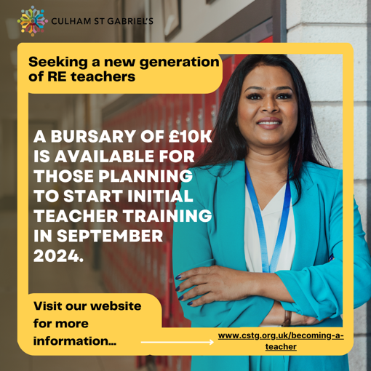
Positive parental opinion of RE is around 70%, with a recognition that the subject prepares young people for life in the modern world.  Becoming an RE teacher is important now more than ever! Time to make a difference: www.cstg.org.uk/becoming-a-teacher  #MakeADifference #TeachingJobs | 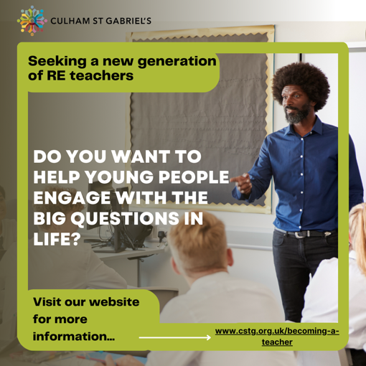
The number of RE teachers has fallen by 1800 (-10.9%) since 2011.  Strong teaching of the subject is needed now more than ever, to help pupils make sense of and navigate our diverse society!  Get involved: http://www.cstg.org.uk/becoming-a-teacher  #MakeADifference #RETeacher | 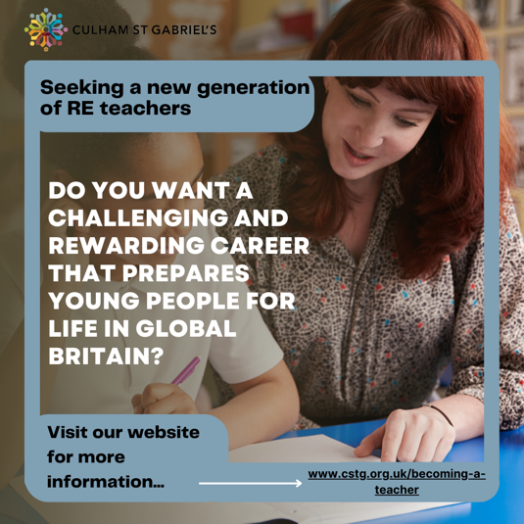
Do you have a degree in one of the fields listed below? [amend last word to say ‘above’ for Instagram post]  Schools and academies are seeking ambitious graduates who can deliver an academic and rigorous curriculum!  Are you up to the challenge? Find out more: www.cstg.org.uk/becoming-a-teacher  #MakeADifference #RETeacher | 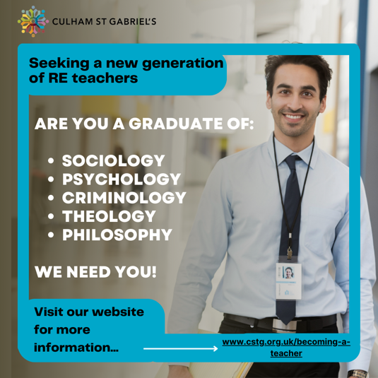
A lack of quality Religious Education can leave young people ill-prepared to understand worldviews, hindering their ability to participate in society.  Urgent action is needed – begin your teaching journey today: www.cstg.org.uk/becoming-a-teacher  #MakeADifference #RETeacher | 
RE is one of the most thought-provoking subjects that equips young people with the skills and knowledge needed to navigate our modern, diverse society and workplace.  Are you thinking of becoming an RE teacher? Visit: www.cstg.org.uk/becoming-a-teacher  #MakeADifference #RETeacher | 